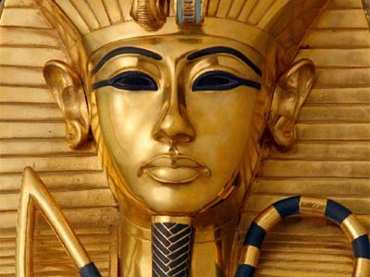
EGYPT: MUMMIES AND PYRAMIDS
This worksheet is thought to help you with the study of this lesson. It is referred to the power point with the same title that we will project in class. The questions follow the order of the slides and there is usually one for each. Try to answer them in class during the explanations or you will have to complete and complete it at home. (You will have access to the PP through the Weebly)

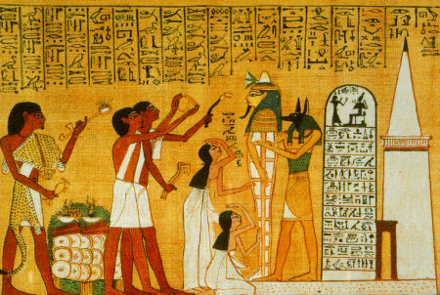
- Why did Egyptians make so many preparations for death and burial?

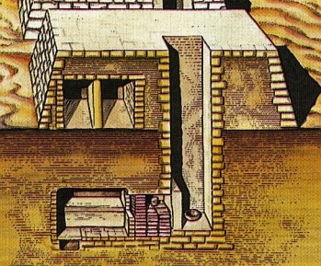
- How were called the first royal tombs?

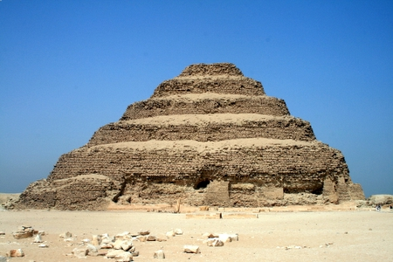
- Why were important Imhotep and Zoser? Who were they?

- When did they construct the first building? And how is it known?

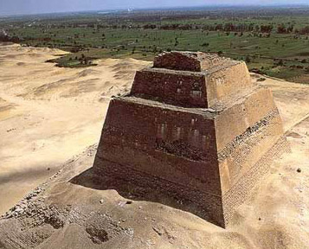

- What type of pyramid built Sneferu first?

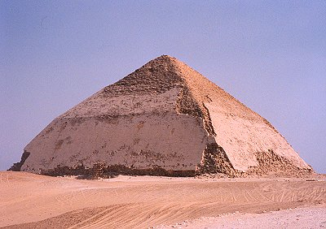

- Why is Bent Pyramid famous for?

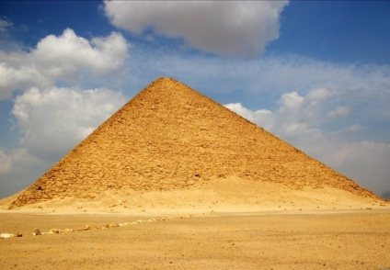
- Which other name receive the Red Pyramid?

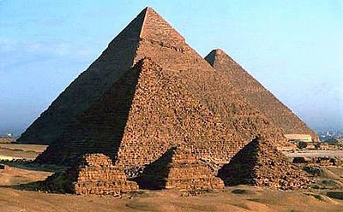
- Which are the most famous pyramids of Egypt?

- Who build the pyramids? Slaves or free men? Why?

- Why did pyramids help to transform Egypt into a powerful and efficient country?

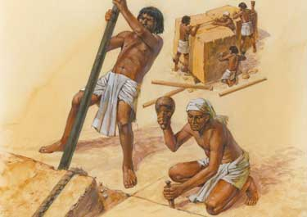
- How long did it take to complete the whole process of a pyramid construction?

- Could you explain the main steps to build a pyramid?

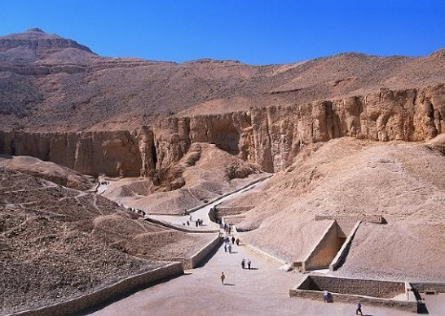
- Which new type of tomb substituted the pyramid? Why? Where were they located?

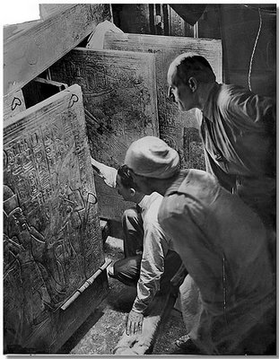
- Which one was the most famous Egyptian tomb? Why?

- Who was the archaeologist that discovered it?

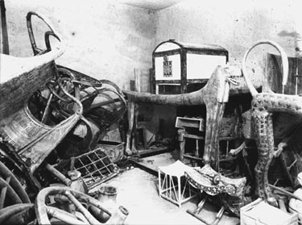
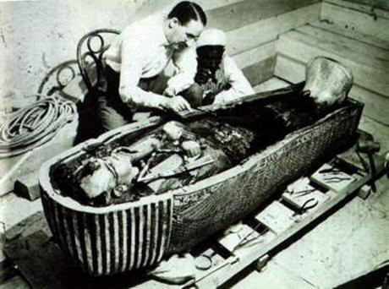

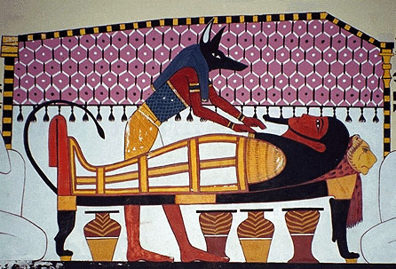

- Why were the mummies made for?

- Who was Anubis?

- What are the Canopic Jars? What are they used for?
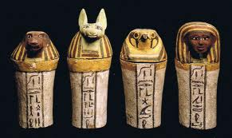

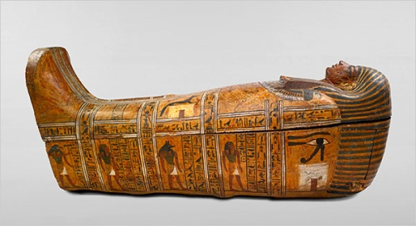
- What is a sarcophagus?

- What is the Book of Dead?
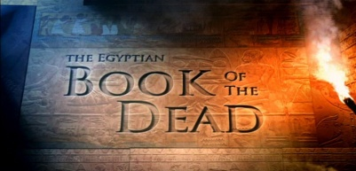

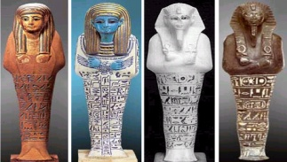
- What are the Ushabtis?

