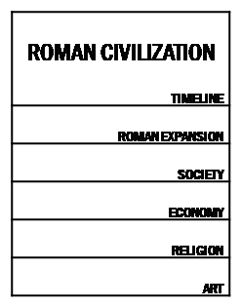
ROMAN CIVILISATION FOLDABLE

- TIMELINE (pages 182 and 183).

- ROMAN EXPANSION: Map of the Roman expansion and concept of Romanisation (186, 3.2).
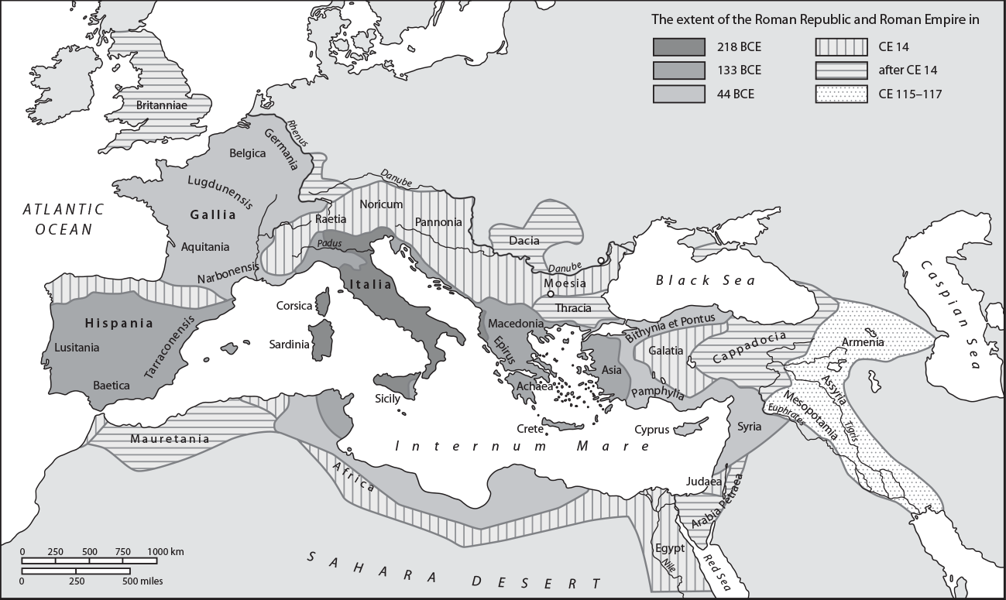
- SOCIETY (190, 5.1)

- ECONOMY: 188: Summarize: Agriculture (4.1), Mining and artisan production (4.2), Trade (4.3).
- RELIGION: 192: Roman Gods (6.1) and Christianty (6.2).
- ART: Architecture: 194: Main characteristics (7.1); Sculpture: 196: Republican and imperial portraits (8.2); Decorative painting and mosaics (8.2).

