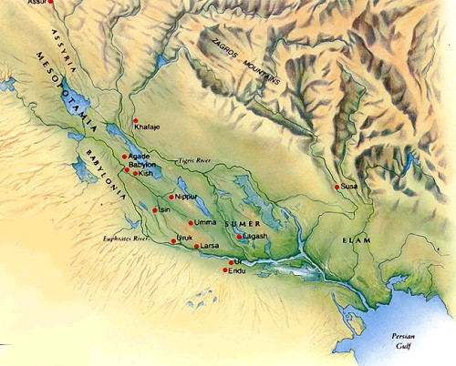
UNIT 9: EARLY CIVILISATIONS
Part 1: River civilizations and Mesopotamia

- Why did early civilisations begin near rivers?

- What were the 4 main river civilizations?

- What does “Mesopotamia” mean?

- What rivers were along the Middle East plains in Mesopotamia?

- Where did people live in ancient Mesopotamia?

- How many important empires developed in ancient Mesopotamia?

- Who were the rulers of the city states from Sumer?

- What is theocracy?

- What is a hierarchical society? Work with the illustration from the Standard of Ur (Identify ranks and social classes following the power point directions)

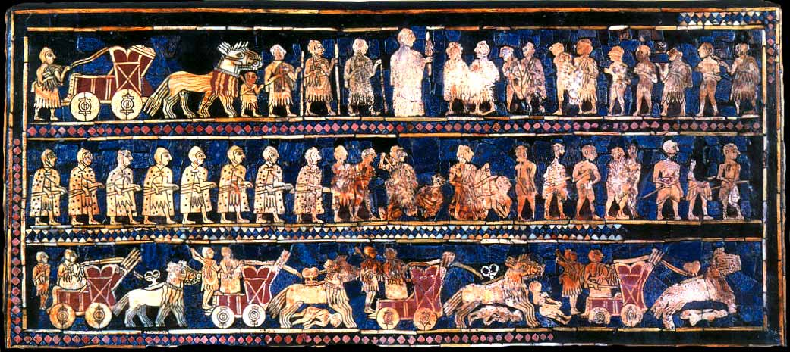

- Complete the pyramid diagram about Mesopotamian Society

- Work with an illustration in groups. What were the main economic activities in Mesopotamia?

- What were the main culture activities of Mesopotamians?

- When did writing appear in Mesopotamia? How is it called? (after watching the video about C.W)

- What was the first use of writing?
- Copy the symbols of cuneiform writing for “food” and “water” and then those of “to drink” and “to eat”

Food | To eat | water | To drink

What do they represent? How do you think are they related?

- Hammurabi´s Code (after watching the two videos about).
What does “an eye for an eye” mean?

Do you think Hammurabi´s code could be apply in our society? Why?

Are there any differences between Hammurabi´s code and our laws?

- Mesopotamian Sculpture
Compare the two reliefs and explain them. Similarities and differences

Compare the two winged bulls. What main differences can you appreciate?

- Mesopotamian Architecture
Which were the main innovations in architecture?

Why do you think aren´t there many Mesopotamian buildings left?

Why do you think many Mesopotamian buildings were made of adobe?

What is a ziggurat?

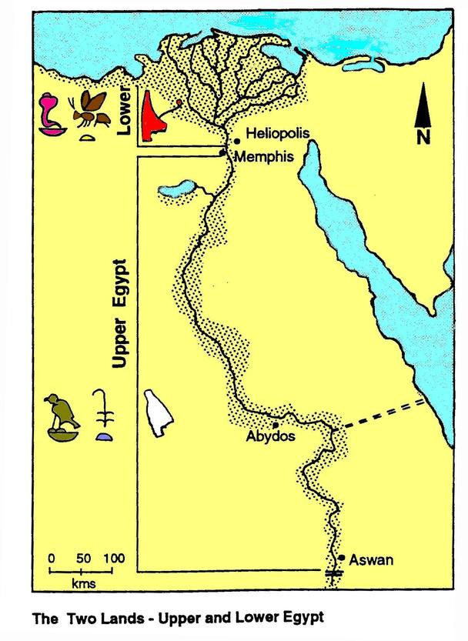
Part 2: Egypt
- Why was the river Nile important for the development of the Egyptian civilization?

- What were the two main regions of Ancient Egypt called?

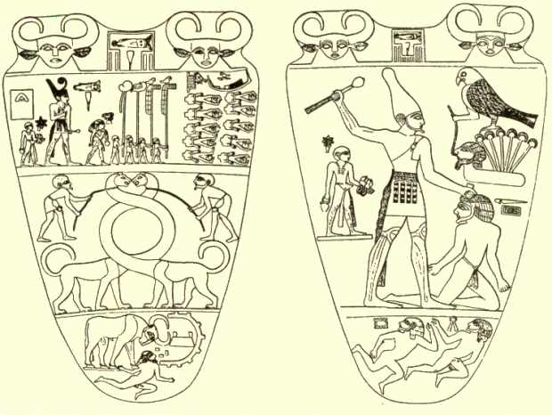
- Describe the images of the “Narmer Relief”

- What were the main periods in ancient Egyptian history?
Name them, give chronologies and indicate the main events or more relevant facts of each period.

- Egyptian Society. Complete the pyramid. Are there any similarities with the Mesopotamian society?

- What were the main economic activities of the Ancient Egypt?

- Why was it important for the Egyptian agriculture to build canals?

- Describe shortly the process used to create writing paper from the papyrus

- What are hieroglyphs?

- Rosetta stone. After watching the video about its discovery:
Why is it important?

Who was J.F. Champollion?

- What does polytheism mean?

- Name the most important Egyptian gods

- Why Egyptians mummified their deads? (Complete BBC activity about “Mummy makers”)

- How were Egyptian sculptures?

- What type of topics represented Egyptian paintings?

- What type of buildings did Egyptians build?

- Name and describe the three main types of Egyptian tombs

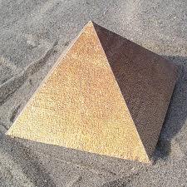
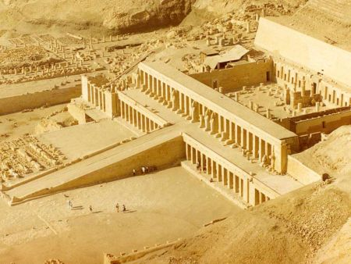
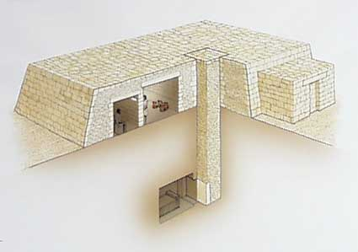

- Parts of an Egyptian temple?

